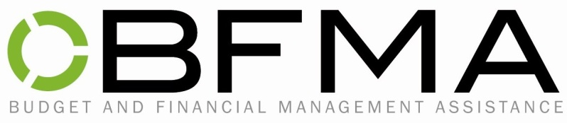

AGREEMENT OF FINANCIAL MANAGEMENT

I, ______________________________________________, agree to have
Budget and Financial Management Assistance (BFMA) deposit and manage my
Social Security entitlement according to a budget developed in my best interest by a representative of BFMA.

I understand BFMA staff may be in consultation with my social service workers.

If needed, BFMA will consult with apartment managers, utility companies, and other creditors in order to formulate proper payment plans.

I agree to allow BFMA to release from my files all financial information required for the resolution of financial issues of my behalf.

I also understand that BFMA is allowed to charge a monthly fee of $44 or 10% (whichever is less) of my total monthly income.

This agreement is in effect from the date of the signature to the termination of services with BFMA.

___________________________________
Signature

__________________________
Date

