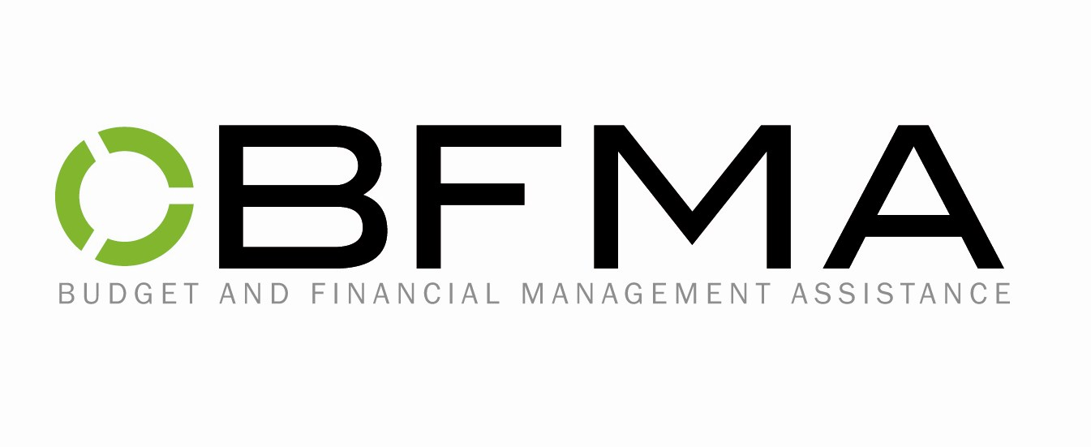

Agreement Letter

The following is a list of things you as the client agree to do while working with BFMA. Please sign and return to BFMA.

- Treat staff with courtesy and respect.
- Provide receipts for all money that is sent to you from BFMA.
- Notify your case worker if you begin/stop working
- Pay stubs need to be sent to your case worker at BFMA.
- Go over your budget with your case worker prior to making any changes to your budget, for example changing cable service.
- Notify your case worker of any changes with whom you live.
- If you intend to move, you must give your Land Lord a 30 day notice, and notify your BFMA case worker prior to the move.

______________________________________________
Signature

____________
Date

