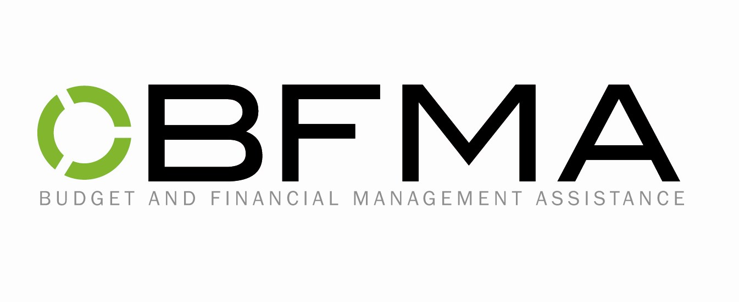

Consent for Release of Information

I, _____________________________________________, authorize

_____________________________________________________________________________
Name and title of person or organization to disclose information
_____________________________________________________________________________
Address
_____________________________________________________________________________
City State Zip Code

To disclose to: BFMA (Budget and Financial Management Assistance)
P.O. Box 414711
Kansas City, MO 64141
Tel. (816) 474-2972 Fax. (816) 474-1673

the following information:

My past and present financial status for the purpose of formulating a payment
plan for the future. Please send future correspondence to me in care of BFMA.

Date___________________________

_______________________________
Signature of Client

_______________________________
Witness

P.O. Box 414711 · Kansas City, Missouri 64141-4711
(816) 474-2972 · Fax: (816) 474-1673 · E-MAIL: BFMA@BFMA-KC.ORG

